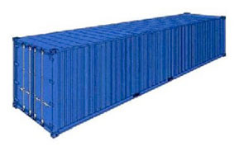
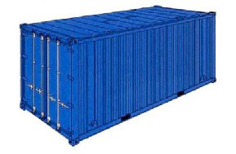

Container Specifications
20 ft. Dry
Container
Length: 5.90m
Width: 2.35m
Height: 2.39m
Door Width:
2.34m
Door Height:
2.27m
Max Payload:
26.19 Ton

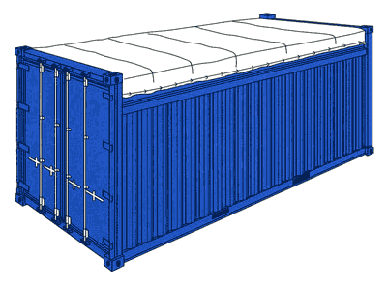
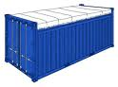
20 ft. Open Top
Container
Length: 5.90m
Width: 2.35,
Height: 2.35m
Door Width:
2.34m
Door Height:
2.24m
Max Payload:
21.55 Ton

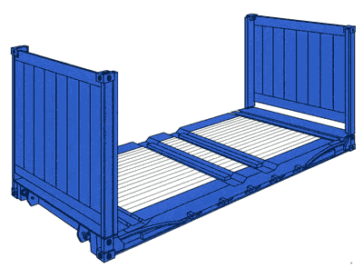
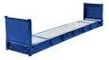
20 ft. Flat Rack
Container
Length: 5.96m
Width: 2.02m
Height: 2.08m
Max Payload:
27.76 Ton

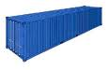
40 ft. High Cube Dry Container Length: 12.03m
Width: 2.35m Height: 2.69m
Door Width: 2.34m
Door Height: 2.58m
Max Payload:
26.49 Ton

40 ft. Dry
Container Length: 12.03m Width: 2.35m Height: 2.39m Door Width:
2.34m Door Height:
2.27m Max Payload:
26.19 Ton

40 ft. Open Top Container
Length: 12.02m
Width: 2.35m
Height: 2.38m
Door Width:
2.34m
Door Height: 24m
Max Payload:
26.46 Ton

40 ft. Flat Rack
Container
Length: 11.99m
Width: 2.34m
Height: 1.97m
Max Payload:
39.46 Ton

45 ft. High Cube Container
Length: 13.58m
Width: 2.34m
Height: 2.69m
Door Width:
2.34m Door Height:
2.58m
Max Payload:
26.18 Ton

